**IS 645 – Database Management Systems**

**Prof: Sock H. Chung, PhD, FLMI**

*Department of Computer Information Systems*

*College of Business*

*Eastern Michigan University*

PROJECT: **PFEP Database for PSMi**

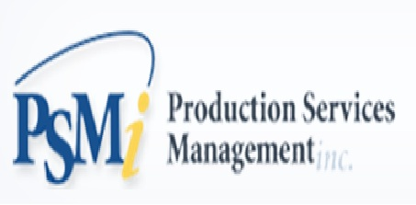

***Team Members:***

*Akshata Desai*

*Jis Thomas*

*Namita Bahulekar*

*Opeyemi Usman*

*Shuting Cui*

**TABLE OF CONTENTS**

**1.** **MEMBER PROFILE** 3

**2.** **EXECUTIVE SUMMARY** 6

**3.** **ABOUT THE ORGANIZATION AND ENVIRONMENTAL ANALYSIS** 7

**4.** **METHODOLOGY /TOOLS SECTION** 14

**5.** **HISTORY OF IT/IS & DATABASE PROJECTS** 20

**6.** **WORK BREAKDOWN STRUCTURE** 21

**7.** **DATABASE DEVELOPMENT PROCESS** 25

**8.** **CONCLUSIONS** 101

**9.** **REFERENCES** 102

**10.** **APPENDICES** 102

## **MEMBER PROFILE**

**Jis Thomas**



Jis Thomas is currently a graduate student in Management Information Systems at Eastern Michigan University (EMU). She also holds the position of graduate research assistant at EMU and Liaison of Quicken Loans. Jis has previously held several technology related positions in a multinational software firm, Wipro Technologies for a period of more than 4 years. She is very passionate about data warehousing and during summer 2017, she interned at Title Source Inc as a Data Warehouse Engineer. Jis has her undergraduate degree in electrical and electronics engineering from Mahatma Gandhi University, India in 2008. She writes poem and stories coming from her heart mainly her own stories. She currently lives in Ann Arbor with two children, Adiv and Neva, and her husband Dr. Albert Thomas.

**Akshata Desai**



Akshata Desai is currently a graduate Student in Computer Information Systems at Eastern Michigan University. Akshata has completed her Bachelor's degree in Computer Science from Gogte Institute of Technology, Belgaum, Karnataka, India. After her Bachelor’s, she has worked as a System Engineer in Tata Consultancy Services for 3 years. She currently lives in Livonia, Michigan with her husband.

**Namitha Bahulekar**



Namita Bahulekar currently works with General Electric (GE Digital) as a software engineer and is also pursuing masters in Information Systems at Eastern Michigan University COB. Namita completed her Bachelor’s degree in Information Technology from Pune University, India. Namita has five years of experience in software development and has worked on various technologies in Java/J2EE technology stack. Namita likes to solve problems and provide solution that creates value. Namita enjoys watercolor painting, she stays in Canton, MI with her husband.

**Shuting Cui**



Shuting Cui is currently pursuing Master of Science in Information System at EMU. She completed her Bachelor’s Degree in Information Technology back in China. She worked for IBM in Beijing for a year and then came to the USA. In summer 2017, during the internship, she became really passionate about Digital Marketing area.

**Opeyemi Usman**



Opeyemi Usman is currently a graduate student in Computer Information Systems at Eastern Michigan University. Opeyemi has completed his Bachelor's degree in Computer Science from University of Lagos, Nigeria. He is a motivated and versatile Information Technology professional. Over the last five (5) years, he has been involved in the delivery of effective Information Technology services both as an IT Governance, Risk and Compliance (GRC) advisor and application developer. He is a consistent hard worker and quick thinker. He is committed to professionally proffering solutions that make a difference and increase efficiency to the industry’s ever-changing environment.

## **EXECUTIVE SUMMARY**

**Lean manufacturing** or **Lean production**, often simply "**lean**", is a systematic method for waste minimization within a manufacturing system without sacrificing productivity. It is extremely important to manage inventory in right quantities, one should not maintain too much or too less inventory. In large factories, with number of departments, number of products, and with number of tools it becomes extremely important to forecast ‘right inventory’ to maintain lean manufacturing process.

The first step in creating a lean material-handling system is to develop a Plan for Every Part (PFEP). The Assembly Planner **Plan for Every Part** (**PFEP**) is an in-plant logistics database which will be used to foster precise, accurate, and controlled inventory reduction, while serving as the foundation for the continuous improvement of a plant's material-handling system. It contains all the critical information about machines, parts, tools, vendors, time required to procure different tools. This information, in turn, can be used to manage the material-handling system, size markets and storage racks containing purchased parts, and decide when to purchase new parts.

Currently this data is maintained in excel sheets which makes system very cumbersome. And data is not reused for analytical purposes. Our sponsor PSMI proposes to develop an application that can be used for **Plan for Every Part** (**PFEP**) in any domain in any factory.

Our team project is to build database management system for **Plan for Every Part** (**PFEP**). PFEP will help Plant Controller to make various forecasts regarding inventory management. It will maintain data about Engineering Disbursement, Financial Disbursement, Production Volumes, Lead Time, Min Quantity, Max Quantity and Value of Inventory. Also, it will help to aggregate cost based on Plant, Cost Center, Lines, Operations, Department, Machine, Holder, Tools etc.

## **ABOUT THE ORGANIZATION AND ENVIRONMENTAL ANALYSIS**

**3.1 Industry**

PSMI was founded in 2005 with the sole objective of increasing operational effectiveness by reducing tooling and MRO spending. PSMI began with a single client in one location. It has since grown exponentially to provide services globally across automotive, aerospace, defense, energy, medical, and agricultural industries. PSMI has helped its customers launch greenfield facilities in the U.S., Mexico, India, and China while generating efficiencies and cost savings in existing facilities.

**PSMI US**

* Managing over 25 manufacturing plants for various products and services across US
* Over 150 employees
* Fully integrated processes between Customer facilities located within US and abroad
* Global Spend Management for our Customers
* Process standardization across the entire Customer Organization
* Domain and category experts for Technical Solutions, Sourcing & Procurement

**PSMI Mexico**

* Over 100 personnel
* Managing over 12 customer facilities
* Helped US suppliers to set up local operations to reduce logistics and import costs
* Provides full process integration between customer’s US & Mexico facilities

**PSMI India**

* Over 30 personnel
* Low-cost country sourcing
* Managing 2 customer facilities
* Full process integration between US/ Mexican and Indian plants
* Back-office support

**PSMI Canada**

* Servicing GM St. Catherine
* Providing Tool Management Services for GM’s GF6 Transmission
* Helping GM standardize processes between Canadian and US Operations

**3.2 Economic**

**Company Mission**

Powering cost savings for the customers is the mission PSMI.

**Cost Savings**

PSMI products and services are deployed in a manner that reduces total operational costs for the clients. They analyze the entire indirect supply chain, processes related to consumption and procurement, quality systems, and the item plan to identify opportunities for cost savings.

**Savings based on Technical solution**

PSMI has over 50 engineers located on-site. All engineers work with clients to help increase throughput while reducing operational costs related to metal cutting.

**Cost Per Unit Reduction**

* Focus on tool life increase
* Track number of regrinds/tool to increase tool utilization rate
* Investigate breakages

**Inventory Reduction**

* Share the spare
* Eliminate obsolete inventory
* Plan for every part algorithms to scale inventory with production demands
* Standardize tools among multiple operations

**Cycle Time Increase**

* Investigate jobs per hour at bottleneck operations
* Align tool life with production demands
* Train operators
* Manage feed and speed
* Eliminate early tool pulls/changeovers

**Procurement and Price Savings**

PSMI also helps consolidate the supply base with key strategic suppliers. By funneling more spending toward a particular supplier, more favorable pricing can be negotiated based on how much will be spent with that supplier in a given year. Many companies may purchase similar items from many suppliers at different prices. By consolidating this “spend,” and directing it toward a select few suppliers, PSMI is able to negotiate a better price for its clients.

PSMI are also able to consolidate purchasing across all clients’ manufacturing plants globally and categorize spending by commodities and rationalize the supply base based on strategy. This ultimately leads to lower prices and a stable supply base. Key performance indicators are established for suppliers, and this data is used to source business.

**Spend Savings**

PSMI helps its clients reduce their overall spending for cutting tools and indirect items. This starts with developing budgets based on production volumes through a proprietary algorithm that takes into account all variables related to product consumption. The budgets are defined by department and the spending is carefully monitored using a methodology called “Checkbook Accounting.” All deviations from the budget are examined, and plans are put into place to manage this budget.

PSMI also provides crib vending machines, tracking of excessive usages, and various notification systems that alert stakeholders when a given process has fallen out of budget. All these processes and methods help our client ***reduce spending***.

**Freight Savings**

PSMI use a hub and spoke model for distribution, like that used by FedEx and UPS whereby all materials are cleared through a central warehouse. This minimizes–possibly eliminates–errors and allows for end-to-end tracking of material from the supplier to our client. Studies have shown that PSMI helped reduce freight costs by up to 30%.

PSMI systems are integrated with the systems of FedEx, UPS, and other large carriers.

**Inventory Savings**

PSMI use sophisticated inventory management systems to help reduce inventory throughout the supply chain. One of the first processes PSMI implement when launching a program is develop a ***Plan for Every Part.*** This process uses all the variables: production volumes, product life, lead times, product category (durable/perishable), product type (repairable/unrepairable), etc. This information is fed into the proprietary algorithm generating a forecast of inventory needed for the planned production volumes. Furthermore, inventory volumes can be flexed in real time as production volumes change due to market demands. Other tools such as barcodes are utilized to track and manage inventories

PSMI uses other methodologies for ***Spare Parts Management***, such as “share the spare” where common spare parts are identified and warehoused centrally and shared across multiple manufacturing departments or facilities globally. PSMI also comb through our clients’ facilities identifying products that can be commonized across multiple operations and facilities. This reduces part number proliferation and allows for lower inventories.

The third area PSMI target is product lead times. PSMI help the clients select off-the-shelf standard products that have shorter lead times. This helps the clients reduce inventory therefore generating cost savings.

**3.3 Services**

**PSMI** provides many services that help manage manufacturing facility operations, reduce overall operating costs, and increase revenue opportunity by increasing manufacturing output. PSMI helped customers generate millions of dollars in cost savings while increasing throughput and quality.

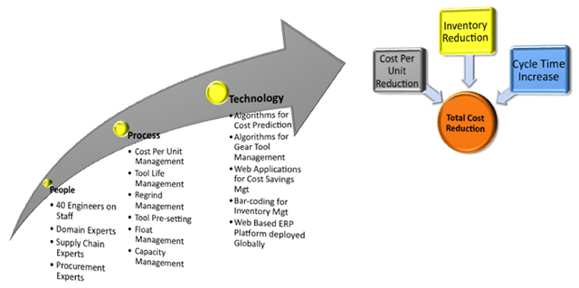

**Tool Technical Support Service**

PSMI’s technical support services reduce cutting and tool spending, and increase throughput and quality for customers. This service has the following attributes:

**Plan for Every Part:**

Plan for every part (PFEP) is a system that defines and sustains information about each part in the value stream:

* Where it comes from
* How it is delivered
* When and how often
* How it should be stored and packaged
* The point of use and when to replenish

A well designed and maintained PFEP system significantly reduces material shortages, inventories, supply chain complexities and costs. PFEP inputs can be supplier/ purchasing, inbound logistics, inbound warehouse, replenishment strategies, internal conveyance, line side presentation. PSMI start with developing a **Plan for Every Part** (PFEP). In this document, every plant operation, tool, theoretical tool life, feeds, speeds, and all other operational variables are documented. This data is fed into **PSMI’s** proprietary algorithm that generates a predictive model for tool spending and inventory needs based on production volumes. These models are then utilized by our customers to set tooling budgets.

**Tool Sufficiency Plans and Cost Savings Deployment:**

PSMI engineers perform a full analysis of customer operations and identify high-cost areas, bottleneck operations, and areas that might be a quality concern. All areas that have an opportunity for improvement are logged into a **PSMI** web-enabled database. These opportunities are reviewed with the client and prioritized for testing. Upon customer approval the new processes are implemented, and cost savings are generated.

**Daily process troubleshooting:**

PSMI engineers also help customers troubleshoot day-to-day manufacturing issues related to cutting tools. These could be related to cycle time improvements, root cause analysis for early tool pulls, throughput issues, or quality concerns.

**SWOT ANALYSIS**



**STRENGTHS**

* Cooperative Team Members
* Effective work schedule and collaboration in cloud.
* Proper direction of faculty and stakeholders.
* Provides application and program independence.
* Proper Audit, Security, Data Management, Consistency and Reliability
* Scope of viewing real-time data.

**THREATS**

* Security
* Several ways of approaching things by team members.
* Work parallelly in Oracle and SQL server.

**OPPORTUNITIES**

* Wonderful opportunity to work as a team for a real project in a product management company.
* Learn thing with proper guidance of faculty, manager and DBA.

**WEAKNESSES**

* Various experience level of team members.
* Difficulty in managing time depending on team schedule.
* If scope and data requirements are unclear, database design can take time and delay project deadlines.

## **METHODOLOGY /TOOLS SECTION**

Through interviewing with our sponsor, we have concluded that these tools will be necessary to design the best diagram we can.

* Microsoft Project
* SQL Server Developer
* Oracle 10g
* RFF (For ERD drafting)
* SQL server 2012
* Forms Builder
* Report Builder

**Facts about Stakeholders**

**Diversity Team Organizational Structure**

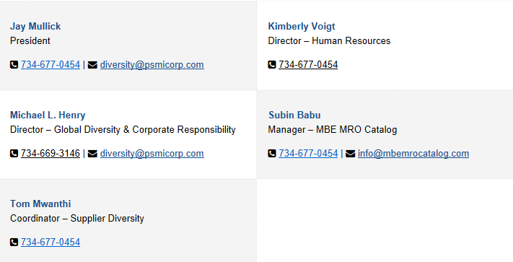

**4.1 Interview**

**Stakeholder 1**

* Name: SUBIN BABU
* Company / Department: PSMI / Diversity Team
* Title / Role: MANAGER
* Primary responsibility: Managing Diversity Team

**Stakeholder 2**

* Name: Mark Brokaw
* Company / Department: PSMI
* Title / Role: DBA
* Primary responsibility: Administrator of Database in PSMI

1. Can you explain about the company PSMI?

PSMI provide services globally across automotive, aerospace, defense, energy, medical, and agricultural industries. In automobile industry, GM is one of our biggest customer. We mainly deal with metal reduction manufacturing which means making shape to a chunk of materials. There is subtractive manufacturing as well as additive manufacturing like welding. The main three chunks of materials we use for this are:

1. cutting tools and abrasives

Each machine does something, assemble things together and produces an end output. And everything requires cutting tools and abrasives.

1. MRO (maintenance repairment operations)

Anything other than cutting tools. Eg: lights, electrical switches, safety glass, hat, gloves

1. Chemicals

Eg: coolants, oils, lubricants

1. What is PFEP?

PFEP means Plan for Every Parts. It is specifically used for cutting tools and abrasives. It mainly deals with the relationship between what I am making and what I need. Things should be available and at the same time it should not be too much. So, always there will be a push and pull between minimizing cash flow and getting inventory. In this scenario, Lean manufacturing or JIT is very important in the reduction of inventory. In simple terms, it is the proper plan for production in automotive plant.

1. Can you explain about the hierarchy and users?

**Hierarchy**

Machine

Operations

Department

Cost center

Plant

**Users:**

**Engineer** –Deals with the theoretical life of the tool, machine. For example, they are responsible for the questions like “am I using right steel? do I need a diamond cutting? how much should I put in machine? etc. Engineer should make report® out of it. They also deal with cost of engine, cost of inventory etc.

**Plant controller:** They deal with distribution (comes from accounting system), financial, production forecast based on season, consumer interest etc. They are responsible for report**®** and maintenance.

**Administrator-** They deals withuser access and hierarchy and are responsible for maintenance.

**Integrated Supplier –** They deals with ideal value orprice. They provide tools, keep information and integrated with supplier with rest of supplier. They are responsible for maintenance.

**Procurement:** It means min/max to set in an ERP system deals with ®- reporting.

Each Transmission have different facets and various features. Each department responsible for particular features. Each department has multiple machines. Machines will do rough boring, drill holes, polish holes, fit bold etc. Each machine has machine hands and tools. Each Factory has multiple departments, machines, heads, tools.

Different transmissions will go through production lines in different department and there will be different productions. There will be many tools and cycles. Output should have all needed parts, department, tools, min order point, max buy point, all machine, all factory and all tools for the inventory management.

1. Can you elaborate on the Physical Infrastructure of the database?

**FACILITY:**

**BUILDING**

COST CENTER (There may be multiple cost centers)

DEPARTMENT (There will be several departments)

LINE

OPERATION

**PRODUCT (PART):**

FEATURE (RELATIONSHIP BETWEEN MACHINE, TOOL, AND PRODUCT)

Eg: THIS TOOL IN THIS MACHINE MAKES THIS FEATURE ON THIS PRODUCT

**TOOL PARAMETERS:**

CUST TOOL NUMBER

TOOL NO

TOOL DESC

VENDOR/MFG

LEAD TIME (DAYS) - TIME TO GET PARTS

COST (CURRENCY)

**MACHINE PARAMETERS:**

TOOL HOLDER

TOOL

MACHINE (BRASS TAG NO)

HOLDERS (LOCATION)

TOOLTYPES

NUMBER OF TOOLS FOR HOLDERS

THEORETICAL LIFE OF TOOL (HOW MANY TYPES BEFORE FAILING)

Eg: ONE MACHINE MAKES ONE PARTS (5000 TRANSMISSION PER DAY)

**PRODUCTION VOLUME:**

PRODUCT

DATE (BY DAY) - CAN AGGREGATE BY WEEK/MONTH

THEORETICAL VOLUME

ACTUAL VOLUME

**FINANCIAL DISBURSEMENT:**

**Only deals with financial, no relationship with production**

DATE OF TRANSACTION

COST OF TOOL

TOOL

COST CENTER

PLANT

DEPARTMENT

**ENGINEERING DISBURSEMENT**

**Deals with Production**

PLANT

DEPARTMENT

OPERATIONS

MACHINE

HOLDER

# CYCLE (PARTS PRODUCED)

1. What are the expected outputs?
2. PFEP DOCUMENT (AGRREGATE AND GROUP/ ROLL UP / ROLL DOWN)
3. High level ERD of PFEP database with the following entities.
4. PLANT, COST CENTER, LINES, OPERATIONS, DEPARTMENT
5. MACHINE, HOLDER, TOOL
6. COST, # PIECES, PRODUCTION VOLUME, LEAD TIME (500 IN A MONTH, HOW MUCH TO STACK OUT?), FORMULA, MIN QUANTITY, MAX QUANTITY, VALUE OF INVENTORY (VOI)
7. A well-structured database for PFEP

## **HISTORY OF IT/IS & DATABASE PROJECTS**

Information technology (IT) is the application of computers to store, study, retrieve, transmit, and manipulate data, or information, often in the context of a business or other enterprise. IT is considered a subset of information and communications technology (ICT). The IT industry was born with the first giant calculators digitally processing and manipulating numbers and then expanded to digitize other, mostly transaction-oriented activities, such as airline reservations.  But until the 1980s, all computer-related activities revolved around interactions between a person and a computer. That did not change when the first PCs arrived on the scene. The PC was simply a mainframe on a desk. Businesses have changed a considerable amount with the utilization of internet and tons of computers. Internet or simply ‘Web’ led to the proliferation of new applications which were no longer limited to enterprise-related activities but digitized almost any activity in our lives. Computer networks (and their “killer app,” email) made the entire process digital, ensuring the proliferation of the message, drastically increasing the amount of data created, stored, moved, and consumed. A new phase in the evolution of IT already is in the market. The cloud—a new way to deliver IT, big data, IoT are the new technologies to save the data. Most observers of the IT industry prefer and are expected to talk about what’s coming, not what’s happened.

Here comes the importance of databases. A database is a collection of information that is organized so that it can be easily accessed, managed and updated. Data is organized into rows, columns on tables, and it is indexed to make it easier to find relevant information. Data gets updated, expanded and deleted as additional information is added. Databases process workloads to create and update themselves, querying the data they contain and running applications against it. Having data in databases not only saves time and preserves vital information, but it allows to see patterns in your operations or able to forecast things that are visible in no other way.

## **WORK BREAKDOWN STRUCTURE**

**System Development Life Cycle**

1. Requirements gathering and analysis

* Collect all the necessary information from the business/company.
* Interviewing the manager and dba of the company.
* Requirements for the application to create database should be determined and understand by each team member.
* Analyze the requirements that are obtained.
* Identify what will be the input to the system.
* What is the scope of the system that will be implemented in the business. (“What work will be done as part of the project?”, “What unique product, service, or result does the customer or sponsor expect from the project?”, or “How will the scope be verified?”)

1. Planning

* Review company’s existing data model.
* Prepare rough draft like ERD (data model) with all entities and attributes.
* Get approval from stakeholders, users, and top management.

1. Design

* Create a database design using data model i.e., relational schema.
* Quality control tuning is done in this stage like integrity constraints and normalization.
* Mentioning data specifications.
* Test strategy will be included in this stage.
* Creating form.
* Creating reports.

1. Implementation

* Loading the data to the system.
* Build the SQL
* Produce documentation.

1. Close-Out

* Conclusion
* What did we learn
* Future Plans

1. Deployment of System
2. Support the Software and Files

**GANTT CHART**

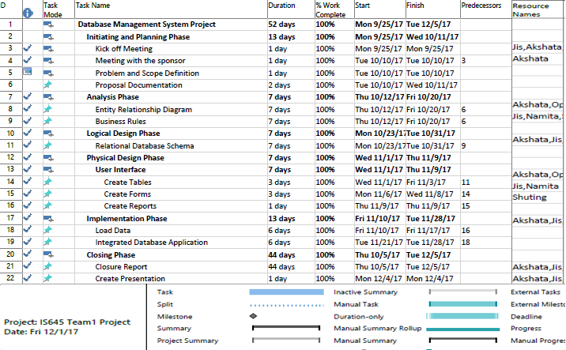

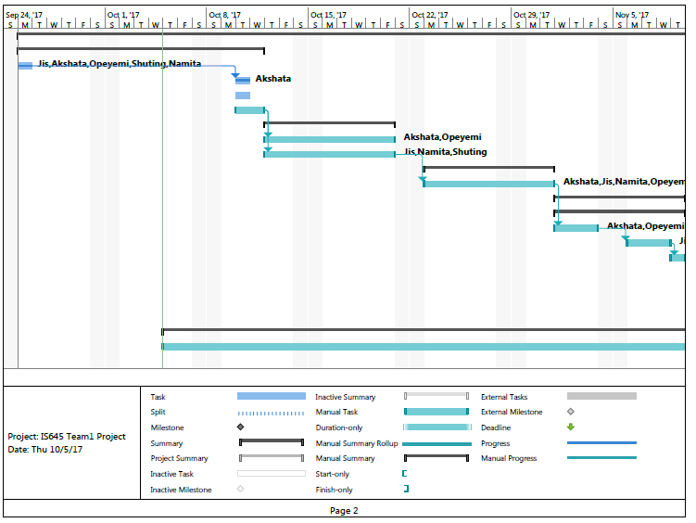

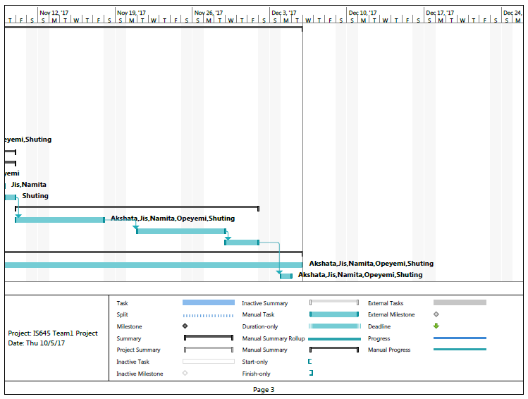

## **DATABASE DEVELOPMENT PROCESS**

**7.1 Entity-Relationship Diagram**

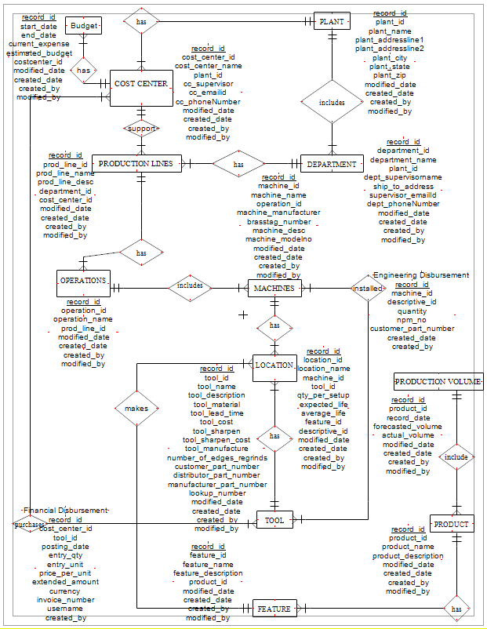

**7.2 Business Rules**

**1. budget - cost center Relationship**

* Each budget is owned by only one cost center
* Each cost center has more than one budget

1. **cost center - plant Relationship**

* Each plant has more than one cost center
* Each cost center is associated with only one plant

1. **cost center – production line Relationship**

* Each production line has only one cost center
* Each cost center may support one or many production lines

1. **department – plant Relationship**

* Each plant has one or many departments
* Each department exist in only one plant

1. **department – production line Relationship**

* Each department has one or more production line
* Each Production line is associated with only one department

1. **Production line – operation Relationship**

* Each production line has more than one operation
* Each operation is in only one production line

1. **machine – operation Relationship**

* Each operation includes one or more machine
* Each machine exists in only one operation

1. **machine - tool. (*This relationship is the Engineering Disbursement)***

* Each machine has one or many installed tools
* Each tool may be installed on one or many machines

1. **machine – location Relationship**

* Each machine has one or more locations
* Each location is on only one machine

1. **location – feature Relationship**

* Each location is associated with only one feature
* Each feature is made by one or more locations

1. **location - tool**

* Each location has only one tool
* Each tool may exist on one or many locations

1. **tool – cost center Relationship. *(The relationship between cost center and tool is financial disbursement)***

* Each tool is associated with more than one cost center
* Each cost center purchases more than one tool

1. **tool – feature Relationship**

* Each tool associated with only one feature
* Each feature is made with one or many tools

1. **feature– product Relationship**

* Each product has more than one feature
* Each feature is associated with only one product

1. **production volume – product Relationship**

* Each production volume entry is associated with only one product.
* Each product may have one or many production volumes entries.

**7.3 Table Structure**

**PLANT** (record_id, plant_id, created_date, created_by, modified_date, modified_by, plant_name, plant_addressline1, plant_addressline2, plant_city, plant_state, plant_zip)

**DEPARTMENT** (, record_id, plant_id, created_date, created_by, department_id, department_name, dept_supervisorname, ship_to_address, supervisor_emailId, dept_phoneNumber, modified_date, modified_by)

**COSTCENTER** (record_id, cost_center_id, cost_center_name, plant_id, cc_supervisor, cc_emailid, cc_phoneNumber, modified_date, created_date, created_by, modified_by)

**BUDGET** (record_id, start_date, end_date, current_expense, estimated_budget, costcenter_id, modified_date, created_date, created_by, modified_by)

**PRODUCTIONLINE** (record_id, prod_line_id, prod_line_name, prod_line_desc, department_id, cost_center_id, modified_date, created_date, created_by, modified_by)

**OPERATION** (record_id, operation_id, operation_name, prod_line_id, modified_date, created_date, created_by, modified_by)

**MACHINE** (record_id, machine_id, machine_name, operation_id, machine_manufacturer, brasstag_number, machine_desc, machine_modelno, modified_date, created_date, created_by, modified_by)

**TOOL** (record_id, tool_id, tool_name, tool_description, tool_material, expected_tool_life, tool_lead_time, tool_cost, tool_sharpen, tool_sharpen_cost, tool_manufacture, number_of_edges_regrinds, customer_part_number, distributor_part_number, manufacturer_part_number, lookup_number, modified_date, created_date, created_by, modified_by)

**FEATURE** (record_id, feature_id, feature_name, feature_description, product_id, modified_date, created_date, created_by, modified_by)

**LOCATION** (record_id, location_id, location_name, machine_id, tool_id, qty_per_setup, expected_life, average_life, feature_id, descriptive_id, modified_date, created_date, created_by, modified_by)

**FINANCIALDISBURSEMENT** (record_id, cost_center_id, tool_id, posting_date, entry_qty, entry_unit, price_per_unit, extended_amount, currency, invoice_number, username, created_by)

**ENGINEERINGDISBURSEMENT** (record_id, machine_id, descriptive_id, quantity, npm_no, customer_part_number, created_date, created_by)

**PRODUCT** (record_id, product_id, product_name, product_description, modified_date, created_date, created_by, modified_by)

**PRODUCTIONVOLUME** (record_id, product_id, record_date, forecasted_volume, actual_volume, modified_date, created_date, created_by, modified_by)

**7.4 Domains**

|  |  |  |
| --- | --- | --- |
| **Attributes** | **Logical** | **Physical** |
| **TABLE:** Plant | | |
| created_by | Maintain user who created the entity | VARCHAR2(25) |
| created_date | Date which plant is processed | DATETIME |
| modified_by | Maintain user who modified the entity | VARCHAR2(25) |
| modified_date | Date which plant is modified | DATETIME |
| plant_addressline1 | Physical Address line 1 of the plant | VARCHAR2(50) |
| plant_addressline2 | Physical Address line 2 of the plant | VARCHAR2(50) |
| plant_city | Plant city name | VARCHAR2(25) |
| plant_id | Unique Key | CHAR(12) |
| plant_name | Name of the Plant | VARCHAR2(25) |
| plant_state | State where plant is located | CHAR(2) |
| plant_zip | Zip code of plant | NUMBER(10) |
| record_id | Primary Key | INTEGER |
| **TABLE:** Department | | |
| created_by | Maintain user who created the entity | VARCHAR2(25) |
| created_date | Date which plant is processed | DATETIME |
| department_id | Unique Key | CHAR(12) |
| department_name | Name of the department | VARCHAR2(25) |
| dept_phoneNumber | Phone number of supervisor | VARCHAR2(25) |
| dept_supervisorname | Name of the supervisor | VARCHAR2(25) |
| modified_by | Maintain user who modified the entity | VARCHAR2(25) |
| modified_date | Date which plant is modified | DATETIME |
| plant_id | Foreign key (Plant table) | CHAR(12) |
| record_id | Primary Key | INTEGER |
| ship_to_code | Address in which shipment should send | VARCHAR2(25) |
| supervisor_emailId | Email id of supervisor | VARCHAR2(25) |
| **TABLE:** CostCenter | | |
| cc_emailid | Email id of supervisor | VARCHAR2(25) |
| cc_phoneNumber | Phone number of supervisor | VARCHAR2(25) |
| cc_supervisor | Name of supervisor | VARCHAR2(25) |
| cost_center_id | Unique Key | CHAR(12) |
| cost_center_name | Name of supervisor | VARCHAR2(25) |
| created_by | Maintain user who created the entity | VARCHAR2(25) |
| created_date | Date which entity is created | DATETIME |
| financial_cc_number | Name of the cost center | VARCHAR2(25) |
| modified_by | Maintain user who modified the entity | VARCHAR2(25) |
| modified_date | Date which entity is modified | DATETIME |
| plant_id | Foreign Key (Plant Table) | CHAR(12) |
| record_id | Primary Key | INTEGER |
| **TABLE:** Budget | | |
| actual_expense | actual expense for each budget | NUMBER(19,2) |
| costcenter_id | Foreign Key (cost center table) | CHAR(12) |
| created_by | Maintain user who created the entity | VARCHAR2(25) |
| created_date | Date which entity is created | DATETIME |
| end_date | end date of budget | DATE |
| estimated_budget | estimated amount | NUMBER(19,2) |
| modified_by | Maintain user who modified the entity | VARCHAR2(25) |
| modified_date | Date which entity is modified | DATETIME |
| record_id | Primary Key | INTEGER |
| start_date | start date of budget | DATE |
| **TABLE:** ProductionLine | | |
| cost_center_id | Foreign key (CostCenter table) | CHAR(12) |
| created_by | Maintain user who created the entity | VARCHAR2(25) |
| created_date | Date which entity is created | DATETIME |
| department_id | Foreign key (Department table) | CHAR(12) |
| modified_by | Maintain user who modified the entity | VARCHAR2(25) |
| modified_date | Date which entity is modified | DATETIME |
| prod_line_desc | description of production line | VARCHAR2(50) |
| prod_line_id | Unique Key | CHAR(12) |
| prod_line_name | name of production line | VARCHAR2(25) |
| record_id | Primary Key | INTEGER |
| **Table:** Operation | | |
| created_by | Maintain user who created the entity | VARCHAR2(25) |
| created_date | Date which entity is created | DATETIME |
| modified_by | Maintain user who modified the entity | VARCHAR2(25) |
| modified_date | Date which entity is modified | DATETIME |
| operation_id | Unique Key | CHAR(12) |
| operation_name | name of operation | VARCHAR2(25) |
| prod_line_id | Foreign key (ProductionLine table) | CHAR(12) |
| record_id | Primary Key | INTEGER |
| **Table:** Machine | | |
|  |  |  |
| bay_location | physical location of the machine | VARCHAR2(25) |
| brasstag_number | BrassTag Number of machine | VARCHAR2(25) |
| created_by | Maintain user who created the entity | VARCHAR2(25) |
| created_date | Date which entity is created | DATETIME |
| eng_machine_number | Machine number connecting engineering disbursement | VARCHAR2(25) |
| machine_desc | Description of machine | VARCHAR2(25) |
| machine_id | Unique Key | CHAR(12) |
| machine_manufacturer | Manufacturer of machine | VARCHAR2(25) |
| machine_modelno | Model number of machine | VARCHAR2(25) |
| machine_name | Name of machine | VARCHAR2(25) |
| modified_by | Maintain user who modified the entity | VARCHAR2(25) |
| modified_date | Date which entity is modified | DATETIME |
| operation_id | Foreign key (Operation Table) | CHAR(12) |
| record_id | Primary Key | INTEGER |
| **Table:** Tool | | |
| created_by | Maintain user who created the entity | VARCHAR2(25) |
| created_date | Date which entity is created | DATETIME |
| customer_part_number | identifier by which tool is used | VARCHAR2(50) |
| distributor_part_number | identifier used by tool distributor | VARCHAR2(50) |
| lookup_number | identifier to look up tools | VARCHAR2(50) |
| manufacturer_part_number | identifier used by manufacturer | VARCHAR2(50) |
| modified_by | Maintain user who modified the entity | VARCHAR2(25) |
| modified_date | Date which entity is modified | DATETIME |
| number_of_edges_regrinds | Number of regrind edges | INTEGER |
| record_id | Primary Key | INTEGER |
| tool_cost | Cost of the tool | NUMBER(19,2) |
| tool_description | Description of tool | VARCHAR2(50) |
| tool_id | Unique Key | VARCHAR2(50) |
| tool_lead_time | time required to procure the tool | INTEGER |
| tool_manufacture | manufacturer of tool | VARCHAR2(25) |
| tool_material | Material of tool | VARCHAR2(50) |
| tool_name | Name of the tool | VARCHAR2(25) |
| tool_sharpen | can tool be regrind? | BOOLEAN |
| tool_sharpen_cost | cost of tool regrinding | NUMBER(19,2) |
| **Table:** Feature | | |
| created_by | Maintain user who created the entity | VARCHAR2(25) |
| created_date | Date which entity is created | DATETIME |
| feature_description | Description of feature | VARCHAR2(50) |
| feature_id | Unique Key | CHAR(12) |
| feature_name | Name of feature | VARCHAR2(25) |
| modified_by | Maintain user who modified the entity | VARCHAR2(25) |
| modified_date | Date which entity is modified | DATETIME |
| product_id | Foreign Key | CHAR(12) |
| record_id | Primary Key | INTEGER |
| **Table:** Location | | |
| average_life | Average life of Tool in a particular location | INTEGER |
| created_by | Maintain user who created the entity | VARCHAR2(25) |
| created_date | Date which entity is created | DATETIME |
| descriptive_id | linked to Engineering Disbursement | VARCHAR2(60) |
| expected_life | Expected life of Tool in a particular location | INTEGER |
| feature_id | Foreign Key | CHAR(12) |
| location_id | Unique Key | CHAR(12) |
| location_name | Name of Location | VARCHAR2(25) |
| machine_id | Foreign Key (Machine table) | CHAR(12) |
| modified_by | Maintain user who modified the entity | VARCHAR2(25) |
| modified_date | Date which entity is modified | DATETIME |
| qty_per_setup | number of tools deployed in a set up | INTEGER |
| record_id | Primary Key | INTEGER |
| tool_id | Foreign Key (Tool table) | CHAR(12) |
| **Table:** FinancialDisbursement | | |
| created_by | Maintain user who created the entity | VARCHAR2(25) |
| created_by | Maintain user who created the entity | VARCHAR2(25) |
| created_date | Date which entity is created | DATE |
| created_date | Date which entity is created | DATE |
| currency | identifier of currency | CHAR(3) |
| customer_part_number | Foreign Key(Tool table) | CHAR(12) |
| descriptive_id | ties back to the location | VARCHAR2(60) |
| eng_machine_number | Foreign Key (Machine Table) | VARCHAR2(25) |
| entry_qty | quantity of tools | INTEGER |
| entry_unit | Unit of tools | CHAR(4) |
| extended_amount | Extended Amount for the tool | NUMBER(19,2) |
| financial_cc_number | Cost center number connecting financial disbursement | VARCHAR2(25) |
| invoice_number | Invoice number of Tool | VARCHAR2(20) |
| posting_date | date at which entry posted | DATE |
| price_per_unit | price of each unit | NUMBER(19,2) |
| quantity | Quantity of disbursement | INTEGER |
| record_id | Primary Key | INTEGER |
| record_id | Primary Key | INTEGER |
| tool_cost | Cost of the tool | NUMBER (19,2) |
| tool_id | Foreign Key (tool table) | CHAR(12) |
| tool_id | Foreign Key (tool table) | VARCHAR2(50) |
| username | Name of the user | VARCHAR2(25) |
| **Table:** Product | | |
| created_date | Date which entity is created | DATE |
| modified_date | Date which entity is modified | DATE |
| product_description | Description of product | VARCHAR2(25) |
| created_by | Maintain user who created the entity | VARCHAR2(25) |
| modified_by | Maintain user who modified the entity | VARCHAR2(25) |
| product_name | Name of the product | VARCHAR2(25) |
| record_id | Primary Key | INTEGER |
| product_id | Unique Key | CHAR (12) |
| **Table:** ProductionVolume | | |
| actual_volume | actual production volume | INTEGER |
| created_by | Maintain user who created the entity | VARCHAR2(25) |
| created_date | Date which entity is created | DATETIME |
| forecasted_volume | forecasted production volume | INTEGER |
| modified_by | Maintain user who modified the entity | VARCHAR2(25) |
| modified_date | Date which entity is modified | DATETIME |
| product_id | Foreign Key (Product table) | NCHAR (12) |
| record_date | date at which volume is recorded | DATETIME |
| record_id | Primary Key | INTEGER |
| **Table Name:** EngineeringDisbursement | | |
| created_by | Maintain user who created the entity | varchar2(25) |
| created_date | Date which entity is created | Datetime |
| customer_part_number | Foreign Key(Tool table) | Char(12) |
| descriptive_id | ties back to the location | varchar2(60) |
| eng_machine_number | Foreign Key (Machine Table) | varchar2(25) |
| quantity | Quantity | Integer |
| record_id | Primary Key | Integer |
| tool_id | Tool Number | varchar2(50) |

**7.5 Constraints**

**Primary Key Constraints**

record_id in Plant must not be null

record_id in Department must not be null

record_id in CostCenter must not be null

record_id in Budget must not be null

record_id in ProductionLine must not be null

record_id in Operations must not be null

record_id in Machine must not be null

record_id in Tool must not be null

record_id in Feature must not be null

**Referential Integrity Constraints**

plant_id in Department must exist in record_id in Plant

plant_id in CostCenter must exist in record_id n Plant

costcenter_id in Budget must exist in record_id _id in CostCenter

department_id in ProductionLine must exist in department_id in Department

cost_center_id in ProductionLine must exist in cost_center_id in CostCenter

prod_line_id in Operations must exist in prod_line_id in ProductionLine

operation_id in Machine must exist in operation_id in Operations

product_id in Feature must exist in product_id in Product

feature_id in Location must exist in feature_id in Feature

machine_id in Location must exist in machine_id in Machine

tool_id in Location must exist in tool_id in Tool

tool_id in FinancialDisbursement must exist in tool_id in Tool

customer_part_number in EngineeringDisbursement must exist in customer_part_number in

Tool

product_id in ProductionVolume must exist in product_id in Product

**Operational Constraints**

tool_sharpen in Tool must be ‘Y’ or ‘N’

**7.6 Implementation of Data**

**7.6.1 Creating of the Tables**

CREATE DATABASE PFEP;

----CREATE TABLE SCRIPT FOR Plant TABLE

CREATE TABLE Plant

(record_id Integer,

plant_id Char(12) unique,

plant_name VARCHAR2(25),

plant_addressline1 VARCHAR2(50),

plant_addressline2 VARCHAR2(50),

plant_city VARCHAR2(25),

plant_state CHAR(2),

plant_zip VARCHAR2(10),

modified_date Date,

created_date Date,

created_by VARCHAR2(25),

modified_by VARCHAR2(25),

CONSTRAINT plant_record_id_pk PRIMARY KEY (record_id));

----CREATE TABLE SCRIPT FOR Department TABLE

CREATE TABLE Department

(record_id Integer ,

department_id Char(12) unique,

department_name VARCHAR2(25),

plant_id Integer,

dept_supervisorname VARCHAR2(25),

ship_to_code VARCHAR2(25),

supervisor_emailid VARCHAR(25),

dept_phoneNumber VARCHAR(25),

modified_date Date,

created_date Date,

created_by VARCHAR2(25),

modified_by VARCHAR2(25),

CONSTRAINT department_record_id_pk PRIMARY KEY (record_id),

CONSTRAINT department_plant_id_fk FOREIGN KEY (plant_id) REFERENCES Plant(record_id));

----CREATE TABLE SCRIPT FOR CostCenter TABLE

CREATE TABLE CostCenter

(record_id Integer ,

financial_cc_number VARCHAR2(25),

cost_center_id CHAR(12) unique,

cost_center_name VARCHAR2(25),

plant_id Integer,

cc_supervisor VARCHAR2(25),

cc_emailid VARCHAR2(25),

cc_phonenumber VARCHAR(25),

modified_date Date,

created_date Date,

created_by VARCHAR2(25),

modified_by VARCHAR2(25),

CONSTRAINT costcenter_record_id_pk PRIMARY KEY (record_id),

CONSTRAINT costcenter_plant_id_fk FOREIGN KEY (plant_id) REFERENCES costcenter(cost_center_id));

----CREATE TABLE SCRIPT FOR Budget TABLE

CREATE TABLE Budget

(record_id Integer ,

start_date Date,

end_date Date,

actual_expense Number,

estimated_budget Number,

cost_center_id CHAR(12),

modified_date Date,

created_date Date,

created_by VARCHAR2(25),

modified_by VARCHAR2(25),

CONSTRAINT budget_record_id_pk PRIMARY KEY (record_id),

CONSTRAINT budget_costcenter_id_fk FOREIGN KEY (cost_center_id) REFERENCES CostCenter(record_id));

----CREATE TABLE SCRIPT FOR PRODUCTION LINE TABLE

CREATE TABLE ProductionLine

( record_id integer,

prod_line_id char(12) unique,

prod_line_name VARCHAR2(25),

prod_line_desc Varchar2(50),

department_id Char(12),

cost_center_id Char(12),

modified_date Date,

created_date Date,

created_by varchar2(25),

modified_by varchar2(25),

CONSTRAINT prodline_record_id_pk PRIMARY KEY (record_id),

CONSTRAINT prodLine_depart_id_fk FOREIGN KEY (department_id) REFERENCES Department(department_id),

CONSTRAINT prodLine_cost_center_id_fk FOREIGN KEY (cost_center_id) REFERENCES CostCenter(cost_center_id));

----CREATE TABLE SCRIPT FOR OPERATION TABLE

CREATE TABLE Operations

( record_id Integer,

operation_id Char(12) unique,

operation_name Varchar2(25),

prod_line_id Char(12),

modified_date Date,

created_date Date,

created_by varchar2(25),

modified_by varchar2(25),

CONSTRAINT operation_record_id_pk PRIMARY KEY (record_id),

CONSTRAINT operation_prod_line_id_fk FOREIGN KEY (prod_line_id) REFERENCES ProductionLine(prod_line_id));

----CREATE TABLE SCRIPT FOR MACHINE TABLE

CREATE TABLE Machine

( record_id Integer,

machine_id Char(12) unique,

machine_name Varchar2(25),

operation_id Char(12),

machine_manufacturer varchar2(25),

brasstag_number varchar2(25),

machine_desc varchar2(25),

machine_modelno varchar2(25),

modified_date Date,

created_date Date,

created_by varchar2(25),

modified_by varchar2(25),

bay_location Varchar2(25),

eng_machine_number Varchar2(25),

CONSTRAINT machine_record_id_pk PRIMARY KEY (record_id),

CONSTRAINT machine_operation_id_fk FOREIGN KEY (operation_id) REFERENCES Operations(operation_id));

----CREATE TABLE SCRIPT FOR TOOL

CREATE TABLE Tool

( record_id Integer,

tool_id varchar2(50) unique,

tool_name Varchar2(25),

tool_description Varchar2(50),

tool_material Varchar2(50),

tool_lead_time Integer,

tool_cost Number,

tool_sharpen Char(1)

CONSTRAINT sharpen_constraint CHECK (tool_sharpen in ( 'Y', 'N' )),

tool_sharpen_cost Number,

tool_manufacture Varchar2(25),

number_of_edges_regrinds Integer,

customer_part_number varchar2(50) unique,

distributor_part_number varchar2(50) unique,

manufacturer_part_number varchar2(50) unique,

lookup_number varchar2(50),

modified_date Date,

created_date Date,

created_by varchar2(25),

modified_by varchar2(25),

CONSTRAINT tool_record_id_pk PRIMARY KEY (record_id));

----CREATE TABLE SCRIPT FOR Product TABLE

CREATE TABLE Product

(record_id Integer ,

product_id Nchar(12) unique,

product_name VARCHAR2(25),

product_description VARCHAR2(50),

modified_date Date,

created_date Date,

created_by VARCHAR2(25),

modified_by VARCHAR2(25));

----CREATE TABLE SCRIPT FOR Feature

CREATE TABLE Feature

(record_id Integer,

feature_id char(12) unique,

feature_name VARCHAR2(25),

feature_description VARCHAR2(50),

product_id NCHAR(12),

modified_date Date,

created_date Date,

created_by VARCHAR2(25),

modified_by VARCHAR2(25),

CONSTRAINT feature_record_id_pk PRIMARY KEY (record_id),

CONSTRAINT feature_product_id_fk FOREIGN KEY (product_id) REFERENCES Product(product_id));

----CREATE TABLE SCRIPT FOR Location TABLE

CREATE TABLE Location

(record_id Integer ,

location_id char(12) unique,

location_name VARCHAR2(25),

tool_id varchar2(50),

machine_id Char(12),

qty_per_setup Integer,

expected_life Integer,

average_life Integer,

feature_id Char(12),

descriptive_id VARCHAR2(60),

modified_date Date,

created_date Date,

created_by VARCHAR2(25),

modified_by VARCHAR2(25),

CONSTRAINT location_record_id_pk PRIMARY KEY (record_id),

CONSTRAINT location_feature_id FOREIGN KEY (feature_id) REFERENCES Feature(feature_id),

CONSTRAINT location_machine_id FOREIGN KEY (machine_id) REFERENCES Machine(machine_id),

CONSTRAINT location_tool_id FOREIGN KEY (tool_id) REFERENCES Tool(tool_id));

----CREATE TABLE SCRIPT FOR FinancialDisbursement TABLE

CREATE TABLE FinancialDisbursement

(record_id Integer,

tool_id varchar2(50) unique,

currency char(3),

entry_qty Integer,

entry_unit char(4),

extended_amount Number,

financial_cc_number VARCHAR2(25),

invoice_number VARCHAR2(20) ,

posting_date Date,

price_per_unit Number,

username VARCHAR2(25),

created_date Date,

created_by VARCHAR2(25),

modified_by VARCHAR2(25),

CONSTRAINT findisb_tool_id FOREIGN KEY (tool_id) REFERENCES Tool(tool_id));

----CREATE TABLE SCRIPT FOR EngineeringDisbursement TABLE

CREATE TABLE EngineeringDisbursement

(record_id Integer ,

customer_part_number VARCHAR2(50),

eng_machine_number VARCHAR2(25),

tool_id VARCHAR2(50),

descriptive_id VARCHAR2(60),

quantity Integer,

tool_cost NUMBER,

created_date Date,

created_by VARCHAR2(25),

CONSTRAINT engdisb_customer_part_number FOREIGN KEY (customer_part_number) REFERENCES Tool(customer_part_number));

----CREATE TABLE SCRIPT FOR ProductionVolume TABLE

CREATE TABLE ProductionVolume

(record_id Integer ,

product_id char(12),

actual_volume integer,

forecasted_volume integer,

created_by VARCHAR2(25),

created_date Date,

modified_date Date,

modified_by VARCHAR2(25),

record_date Date,

CONSTRAINT productionvolume_product_id FOREIGN KEY (product_id) REFERENCES Product(product_id));

**7.6.2 Adding Data to the Tables**

-- Plant Insert

insert into plant(record_id,plant_id,plant_name,plant_addressline1,plant_addressline2,plant_city,

plant_state,plant_zip,modified_date,created_date,created_by,modified_by) values

( 1,

'5234',

'Rear Wheel Transmission',

'3457 Birch St',

null,

'Ypsilanti',

'MI',

'48197',

'05-NOV-2017',

'05-NOV-2017',

'nbahulek',

'nbahulek');

insert into plant(record_id,plant_id,plant_name,plant_addressline1,plant_addressline2,plant_city,

plant_state,plant_zip,modified_date,created_date,created_by,modified_by) values

( 2,

'5233',

'Front Wheel 6 Speed',

'3457 Birch St',

null,

'Canton',

'FL',

'44197',

'06-NOV-2017',

'07-NOV-2017',

'nbahulek',

'nbahulek');

insert into plant(record_id,plant_id,plant_name,plant_addressline1,plant_addressline2,plant_city,

plant_state,plant_zip,modified_date,created_date,created_by,modified_by) values

( 3,

'5236',

'Front Wheel 8 Speed',

'3457 Primrose St',

null,

'Canton',

'MI',

'44197',

'08-NOV-2017',

'09-NOV-2017',

'adesai',

'adesai');

insert into plant(record_id,plant_id,plant_name,plant_addressline1,plant_addressline2,plant_city,

plant_state,plant_zip,modified_date,created_date,created_by,modified_by) values

( 4,

'5235',

'Front Wheel 6 Speed',

'3457 Primrose St',

null,

'Troy',

'MI',

'44197',

'08-NOV-2017',

'10-NOV-2017',

'adesai',

'adesai');

-- Department Insert

INSERT INTO Department( record_id, department_id, department_name, plant_id, dept_supervisorname, ship_to_code,

supervisor_emailid, dept_phoneNumber, modified_date, created_date, created_by, modified_by)

VALUES (

1,

'DEP1',

'Transmission',

1,

'Jack Stevens',

'67778',

'jstevens@abccorp.com',

'454-000-9090',

'06-NOV-2017',

'06-NOV-2017',

'nbahulek',

'nbahulek');

INSERT INTO Department( record_id, department_id, department_name, plant_id, dept_supervisorname, ship_to_code,

supervisor_emailid, dept_phoneNumber, modified_date, created_date, created_by, modified_by)

VALUES (

2,

'DEP2',

'PINION GEAR-GREEN',

1,

'Jackie Stevens',

'67778',

'jstevens1@abccorp.com',

'454-000-9090',

'06-NOV-2017',

'08-NOV-2017',

'nbahulek',

'nbahulek');

INSERT INTO Department( record_id, department_id, department_name, plant_id, dept_supervisorname, ship_to_code,

supervisor_emailid, dept_phoneNumber, modified_date, created_date, created_by, modified_by)

VALUES (

3,

'DEP3',

'PINION GEAR-HARD',

3,

'ABC RT',

'67778',

'jstevens@abccorp.com',

'454-000-9990',

'07-NOV-2017',

'09-NOV-2017',

'jthomas',

'jthomas');

INSERT INTO Department( record_id, department_id, department_name, plant_id, dept_supervisorname, ship_to_code,

supervisor_emailid, dept_phoneNumber, modified_date, created_date, created_by, modified_by)

VALUES (

4,

'DEP4',

'SUN GEAR - GREEN',

4,

'XYZ Stevens',

'67778',

'xstevens@abccorp.com',

'454-000-9990',

'07-NOV-2017',

'09-NOV-2017',

'jthomas',

'jthomas');

-- CostCenter Insert

INSERT INTO CostCenter ( record_id, financial_cc_number, cost_center_id, cost_center_name, plant_id, cc_supervisor,cc_emailid, cc_phonenumber, modified_date, created_date, created_by, modified_by)

VALUES (1,

'1-financial-cc-num',

'CC1',

'ManufacturingPlantCC',

1,

'Emily March',

'emarch@abccorp.com',

'212-898-0000',

'07-NOV-2017',

'07-NOV-2017',

'nbahulek',

'nbahulek');

INSERT INTO CostCenter ( record_id, financial_cc_number, cost_center_id, cost_center_name, plant_id, cc_supervisor,

cc_emailid, cc_phonenumber, modified_date, created_date, created_by, modified_by)

VALUES (2,

'2-financial-cc-num',

'CC2',

'ManufacturingAutoCC',

2,

'Frank March',

'fmarch@abccorp.com',

'212-898-0001',

'07-NOV-2017',

'07-NOV-2017',

'opey',

'opey');

INSERT INTO CostCenter ( record_id, financial_cc_number, cost_center_id, cost_center_name, plant_id, cc_supervisor,

cc_emailid, cc_phonenumber, modified_date, created_date, created_by, modified_by)

VALUES (3,

'3-financial-cc-num',

'CC3',

'CuttinToolCC',

3,

'Joseph March',

'jmarch@abccorp.com',

'212-898-0000',

'08-NOV-2017',

'09-NOV-2017',

'nbahulek',

'nbahulek');

INSERT INTO CostCenter ( record_id, financial_cc_number, cost_center_id, cost_center_name, plant_id, cc_supervisor,

cc_emailid, cc_phonenumber, modified_date, created_date, created_by, modified_by)

VALUES (4,

'4-financial-cc-num',

'CC4',

'ManufacturingPlantCC',

4,

'Lisa March',

'lmarch@abccorp.com',

'212-898-0000',

'07-NOV-2017',

'07-NOV-2017',

'nbahulek',

'nbahulek');

-- Budget Insert

insert into Budget (record_id, start_date, end_date, actual_expense, estimated_budget, cost_center_id, modified_date,

created_date, created_by, modified_by) VALUES

(1,

'01-JAN-2017',

'01-JAN-2018',

'99789',

'7500',

‘CC1’,

'08-NOV-2017',

'09-NOV-2017',

'nbahulek',

'nbahulek');

insert into Budget (record_id, start_date, end_date, actual_expense, estimated_budget, cost_center_id, modified_date,

created_date, created_by, modified_by) VALUES

(2,

'01-JAN-2017',

'01-JAN-2018',

'777777890',

'8888888890',

‘CC2’,

'08-NOV-2017',

'09-NOV-2017',

'nbahulek',

'nbahulek');

insert into Budget (record_id, start_date, end_date, actual_expense, estimated_budget, cost_center_id, modified_date,

created_date, created_by, modified_by) VALUES

(3,

'01-JAN-2017',

'01-JAN-2018',

'5000000',

'8000000',

‘CC3’,

'08-NOV-2017',

'09-NOV-2017',

'shuting',

'shuting');

insert into Budget (record_id, start_date, end_date, actual_expense, estimated_budget, cost_center_id, modified_date,

created_date, created_by, modified_by) VALUES

(4,

'01-JAN-2017',

'01-JAN-2018',

'5000078',

'8008900',

‘CC4’,

'08-NOV-2017',

'09-NOV-2017',

'shuting',

'shuting');

-- ProductionLine insert

insert into productionline(record_id, prod_line_id, prod_line_name, prod_line_desc, department_id, cost_center_id, modified_date, created_date, created_by, modified_by)

VALUES

(1,

'Pline1',

'GmProductionLine',

'GmPontiac',

'DEP1',

'CC1',

'08-NOV-2017',

'09-NOV-2017',

'shuting',

'shuting');

insert into productionline(record_id, prod_line_id, prod_line_name, prod_line_desc, department_id, cost_center_id, modified_date, created_date, created_by, modified_by)

VALUES

(2,

'Pline2',

'GmSupplyProduction',

'GmAnnArbor',

'DEP2',

'CC2',

'08-NOV-2017',

'09-NOV-2017',

'Reena',

'Reena');

insert into productionline(record_id, prod_line_id, prod_line_name, prod_line_desc, department_id, cost_center_id, modified_date, created_date, created_by, modified_by)

VALUES

(3,

'Pline3',

'GmManufactureProduction',

'GmAnnArbor',

'DEP3',

'CC2',

'04-NOV-2017',

'04-NOV-2017',

'Reena',

'Reena');

insert into productionline(record_id, prod_line_id, prod_line_name, prod_line_desc, department_id, cost_center_id, modified_date, created_date, created_by, modified_by)

VALUES

(4,

'Pline4',

'GmHardwareProduction',

'GmNovi',

'DEP4',

'CC3',

'08-NOV-2017',

'08-NOV-2017',

'Namita',

'Namita');

-- Operation insert

insert into operation(record_id, operation_id, operation_name, prod_line_id, modified_date,created_date, created_by, modified_by)

VALUES

(1,

'Operation1',

'GmSupplyOperation',

'Pline1',

'08-NOV-2017',

'08-NOV-2017',

'Opeyami',

'Opeyami');

insert into operations(record_id, operation_id, operation_name, prod_line_id, modified_date,created_date, created_by, modified_by)

VALUES

(2,

'Operation2',

'GmManufacturing',

'Pline2',

'08-NOV-2017',

'08-NOV-2017',

'Jis',

'Jis');

insert into operation(record_id, operation_id, operation_name, prod_line_id, modified_date,created_date, created_by, modified_by)

VALUES

(3,

'Operation3',

'GmManufacturing',

'Pline3',

'08-NOV-2017',

'08-NOV-2017',

'Namita',

'Namita');

insert into operation(record_id, operation_id, operation_name, prod_line_id, modified_date,created_date, created_by, modified_by)

VALUES

(4,

'Operation4',

'GmManufacturing',

'Pline3',

'08-NOV-2017',

'08-NOV-2017',

'Opey',

'Opey');

-- Machine insert

insert into machine(record_id, machine_id, machine_name, operation_id, machine_manufacturer, brasstag_number, machine_desc, machine_modelno, modified_date, created_date, created_by, modified_by,bay_location,eng_machine_number)

VALUES

(1,

'Machine1',

'InsertMachine',

'Operation1',

'GmManufacturer',

'BrassTag1',

'MachineToInsert',

'MachineModel1',

'08-NOV-2017',

'08-NOV-2017',

'Opey',

'Opey',

'SectionA',

'Machine123');

insert into machine(record_id, machine_id, machine_name, operation_id, machine_manufacturer, brasstag_number, machine_desc, machine_modelno, modified_date, created_date, created_by, modified_by,bay_location,eng_machine_number)

VALUES

(2,

'Machine2',

'InsertMachine',

'Operation2',

'GmManufacturer',

'BrassTag1',

'MachineToInsert',

'MachineModel2',

'08-NOV-2017',

'08-NOV-2017',

'Opey',

'Opey',

'Sectionb',

'Machine183');

insert into machine(record_id, machine_id, machine_name, operation_id, machine_manufacturer, brasstag_number, machine_desc, machine_modelno, modified_date, created_date, created_by, modified_by,bay_location,eng_machine_number)

VALUES

(3,

'Machine3',

'DrillMachine',

'Operation3',

'GmManufacturer',

'BrassTag3',

'MachineToInsert',

'MachineModel3',

'08-NOV-2017',

'08-NOV-2017',

'Opey',

'Opey',

'SectionC',

'Machine23');

insert into machine(record_id, machine_id, machine_name, operation_id, machine_manufacturer, brasstag_number, machine_desc, machine_modelno, modified_date, created_date, created_by, modified_by,bay_location,eng_machine_number)

VALUES

(4,

'Machine4',

'MattMachine',

'Operation4',

'GmSupply',

'BrassTag4',

'MachineDrill',

'MachineModel4',

'08-NOV-2017',

'08-NOV-2017',

'Jis',

'Jis',

'SectionD',

'Machine1833');

-- Tool insert

insert into tool(record_id,tool_id,tool_name, tool_description, tool_material,tool_lead_time,tool_cost, tool_sharpen, tool_sharpen_cost, tool_manufacture, number_of_edges_regrinds, customer_part_number, distributor_part_number, manufacturer_part_number, lookup_number, modified_date, created_date, created_by, modified_by)

VALUES

(1,

'InsertTool',

'Insertion',

'ToolUsedtoInsertHoles',

'Carbide',

10,

200,

'Y',

300,

'ToolMfg_mrf',

4,

'CustomerPart1',

'DistributorPart1',

'ManufacturerPart1',

'Lookup1',

'08-NOV-2017',

'08-NOV-2017',

'Jis',

'Jis'

);

insert into tool(record_id,tool_id,tool_name, tool_description, tool_material,tool_lead_time,tool_cost, tool_sharpen, tool_sharpen_cost, tool_manufacture, number_of_edges_regrinds, customer_part_number, distributor_part_number, manufacturer_part_number, lookup_number, modified_date, created_date, created_by, modified_by)

VALUES

(2,

'DrillTool',

'Drill',

'ToolUsedtoDrillHoles',

'Carbide',

30,

200,

'N',

300,

'ToolMfg_mrf',

4,

'CustomerPart2',

'DistributorPart2',

'ManufacturerPart2',

'Lookup1',

'08-NOV-2017',

'08-NOV-2017',

'Reena',

'Reena'

);

insert into tool(record_id,tool_id,tool_name, tool_description, tool_material,tool_lead_time,tool_cost, tool_sharpen, tool_sharpen_cost, tool_manufacture, number_of_edges_regrinds, customer_part_number, distributor_part_number, manufacturer_part_number, lookup_number, modified_date, created_date, created_by, modified_by)

VALUES

(3,

'FurnishedTool',

'FurnishedTool1',

'ToolUsedtofurnish',

'Carbide',

30,

200,

'N',

300,

'ToolMfg_mrf',

4,

'CustomerPart3',

'DistributorPart3',

'ManufacturerPart3',

'Lookup3',

'08-NOV-2017',

'08-NOV-2017',

'Akshata',

'Akshata'

);

insert into tool(record_id,tool_id,tool_name, tool_description, tool_material,tool_lead_time,tool_cost, tool_sharpen, tool_sharpen_cost, tool_manufacture, number_of_edges_regrinds, customer_part_number, distributor_part_number, manufacturer_part_number, lookup_number, modified_date, created_date, created_by, modified_by)

VALUES

(4,

'MakeTool',

'MakeTool1',

'ToolUsedforMaking',

'Carbide',

30,

200,

'Y',

300,

'ToolMfg_mrf',

4,

'CustomerPart4',

'DistributorPart4',

'ManufacturerPart4',

'Lookup3',

'08-NOV-2017',

'08-NOV-2017',

'Akshata',

'Akshata'

);

--Product insertion

INSERT INTO Product(record_id, product_id, product_name, product_description, modified_date,created_date, created_by, modified_by) VALUES

(1,

'T0120',

'2010 engine',

'engine for Ford 2010',

'08-NOV-2017',

'09-NOV-2017',

'shuting',

'shuting');

insert into Product (record_id, product_id, product_name, product_description, modified_date,

created_date, created_by, modified_by) VALUES

(2,

'T0130',

'2011 engine',

'engine for Toyota 2011',

'08-NOV-2017',

'09-NOV-2017',

'shuting',

'shuting');

insert into Product (record_id, product_id, product_name, product_description, modified_date,

created_date, created_by, modified_by) VALUES

(3,

'T0140',

'2012 engine',

'2012 engine for GM 2012',

'08-NOV-2017',

'09-NOV-2017',

'shuting',

'shuting');

insert into Product (record_id, product_id, product_name, product_description, modified_date,

created_date, created_by, modified_by) VALUES

(4,

'T0150',

'2013 engine',

'2013 engine for Honda 2013',

'08-NOV-2017',

'09-NOV-2017',

'shuting',

'shuting');

--Feature Insertion

insert into Feature (record_id, feature_id,feature_name, feature_description,

product_id, modified_date,created_date, created_by, modified_by) VALUES

(1,

'T0150',

'The Claw Hammer',

'T0155',

'T0120',

'10-NOV-2017',

'11-NOV-2017',

'shuting',

'shuting' );

insert into Feature (record_id, feature_id,feature_name, feature_description,

product_id, modified_date,created_date, created_by, modified_by) VALUES

(2,

'T0151',

'The Tape Measure',

'T0920',

'T0130',

'10-NOV-2017',

'11-NOV-2017',

'shuting',

'shuting' );

insert into Feature (record_id, feature_id,feature_name, feature_description,

product_id, modified_date,created_date, created_by, modified_by) VALUES

(3,

'T0153',

'The Utility Knife',

'T0920',

'T0140',

'10-NOV-2017',

'11-NOV-2017',

'shuting',

'shuting' );

insert into Feature (record_id, feature_id,feature_name, feature_description,

product_id, modified_date,created_date, created_by, modified_by) VALUES

(4,

'T0159',

'The Chisel',

'T0920',

'T0140',

'10-NOV-2017',

'11-NOV-2017',

'shuting',

'shuting' );

--Location Insert

insert into Location (record_id, location_id,location_name, machine_id,

tool_id, qty_per_setup, expected_life, average_life, feature_id, descriptive_id, modified_date, created_date, created_by, modified_by) VALUES

(1,

'T0150',

'Novi',

'Machine1',

'InsertTool',

2,

5,

3,

'T0150',

'PSX250-H-060-003-3.6L-INT-224',

'10-NOV-2017',

'11-NOV-2017',

'shuting',

'shuting' );

insert into Location (record_id, location_id,location_name, machine_id,

tool_id, qty_per_setup, expected_life, average_life, feature_id, descriptive_id, modified_date, created_date, created_by, modified_by) VALUES

(1,

'T0151',

'Novi',

'Machine2',

'DrillTool',

2,

5,

3,

'T0151',

'PSX250-H-060-003-3.6L-INT-224',

'10-NOV-2017',

'11-NOV-2017',

'shuting',

'shuting' );

insert into Location (record_id, location_id,location_name, machine_id,

tool_id, qty_per_setup, expected_life, average_life, feature_id, descriptive_id, modified_date, created_date, created_by, modified_by) VALUES

(3,

'T0152',

'Novi',

'Machine3',

'DrillTool',

2,

5,

3,

'T0159',

'PSX250-H-060-003-3.6L-INT-224',

'10-NOV-2017',

'11-NOV-2017',

'Jis',

'Jis' );

insert into Location (record_id, location_id,location_name, machine_id,

tool_id, qty_per_setup, expected_life, average_life, feature_id, descriptive_id, modified_date, created_date, created_by, modified_by) VALUES

(4,

'T0153',

'Novi',

'Machine4',

'DrillTool',

2,

5,

3,

'T0151',

'PSX250-H-060-003-3.6L-INT-224',

'10-NOV-2017',

'11-NOV-2017',

'shuting',

'shuting' );

--- inserting records into FinancialDisbursement

INSERT INTO FinancialDisbursement VALUES

(1, 'InsertTool', 'USD', -1, 'EA', 5, '52070710', '2001210043', '10-NOV-2017', 10.2, 'T0646BP','10-NOV-2017','JIS','NAMITHA');

INSERT INTO FinancialDisbursement VALUES

(2, 'DrillTool', 'USD', -1, 'EA', 5, '52070800', '2001199637', '10-NOV-2017', 10.5, 'T1991DW','10-NOV-2017','JIS','AKSHATA');

INSERT INTO FinancialDisbursement VALUES

(3, 'FurnishedTool', 'USD', -1, 'EA', 5, '52072880', '2001194640', '10-NOV-2017', 10.3, 'T0646BP','10-NOV-2017','JIS','OPEY');

INSERT INTO FinancialDisbursement VALUES

(4, 'MakeTool', 'USD', -1, 'EA', 5, '52070270', '2001199637', '10-NOV-2017', 10.8, 'T1991DW','10-NOV-2017','JIS','SHUTING');

--- inserting records into EngineeringDisbursement

INSERT INTO EngineeringDisbursement VALUES

(1, 'CustomerPart1', '112', '1123D', 'PSX250-H-060-002-3.6L-EXH-224', 4, 9.9, '10-NOV-2017','JIS');

INSERT INTO EngineeringDisbursement VALUES

(2, 'CustomerPart2', '113', '1123B', 'PSX250-H-060-003-3.6L-INT-224', 1, 13.82, '10-NOV-2017','JIS');

INSERT INTO EngineeringDisbursement VALUES

(3, 'CustomerPart3', '114', '1123C', 'PSX250-H-060-006-0-S-001-001-225', 2, 117.62, '10-NOV-2017','JIS');

INSERT INTO EngineeringDisbursement VALUES

(4, 'CustomerPart4', '115', '1123E', 'PSX250-H-060-011-3.6L-INT-FINISH-227', 8, 84.38, '10-NOV-2017','JIS');

--Insertion for ProductionVolume

insert into ProductionVolume (record_id, product_id, record_date, forecasted_volume,

actual_volume, modified_date, created_date, created_by, modified_by) VALUES

(1,

'T0120',

'08-NOV-2017',

500,

700,

'08-NOV-2017',

'09-NOV-2017',

'shuting',

'shuting');

insert into ProductionVolume (record_id, product_id, record_date, forecasted_volume,

actual_volume, modified_date, created_date, created_by, modified_by) VALUES

(2,

'T0130',

'08-NOV-2017',

1000,

800,

'08-NOV-2017',

'09-NOV-2017',

'shuting',

'shuting');

insert into ProductionVolume (record_id, product_id, record_date, forecasted_volume,

actual_volume, modified_date, created_date, created_by, modified_by) VALUES

(3,

'T0140',

'08-NOV-2017',

600,

600,

'08-NOV-2017',

'09-NOV-2017',

'shuting',

'shuting');

insert into ProductionVolume (record_id, product_id, record_date, forecasted_volume,

actual_volume, modified_date, created_date, created_by, modified_by) VALUES

(4,

'T0150',

'08-NOV-2017',

1050,

950,

'08-NOV-2017',

'09-NOV-2017',

'shuting',

'shuting');

insert into ProductionVolume (record_id, product_id, record_date, forecasted_volume,

actual_volume, modified_date, created_date, created_by, modified_by) VALUES

(5,

'T0120',

'10-NOV-2017',

1140,

1150,

'10-NOV-2017',

'11-NOV-2017',

'shuting',

'shuting');

insert into ProductionVolume (record_id, product_id, record_date, forecasted_volume,

actual_volume, modified_date, created_date, created_by, modified_by) VALUES

(6,

'T0130',

'10-NOV-2017',

50,

20,

'10-NOV-2017',

'11-NOV-2017',

'shuting',

'shuting');

insert into ProductionVolume (record_id, product_id, record_date, forecasted_volume,

actual_volume, modified_date, created_date, created_by, modified_by) VALUES

(7,

'T0140',

'10-NOV-2017',

870,

880,

'10-NOV-2017',

'11-NOV-2017',

'shuting',

'shuting');

insert into ProductionVolume (record_id, product_id, record_date, forecasted_volume,

actual_volume, modified_date, created_date, created_by, modified_by) VALUES

(8,

'T0150',

'10-NOV-2017',

786,

899,

'10-NOV-2017',

'11-NOV-2017',

'shuting',

'shuting');

**7.7 Forms**

**7.7.1 Main Page**

-- Main Form Trigger

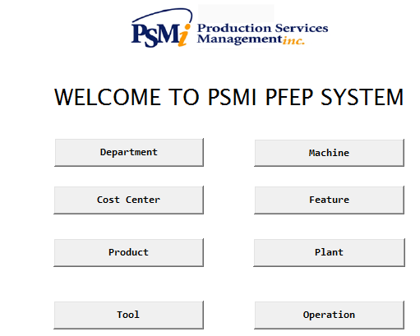

**Department**

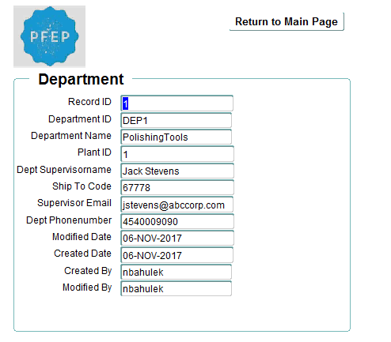

**Feature-Location**

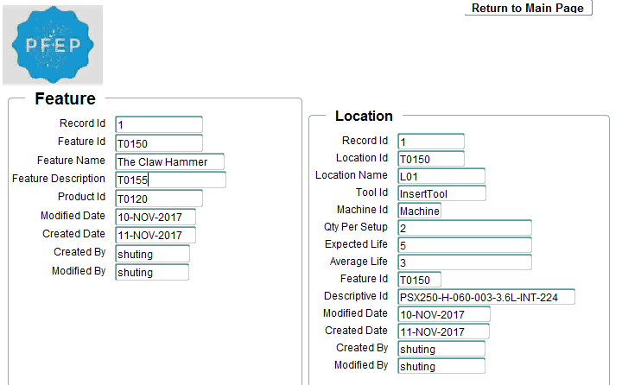

**Plant-Department-ProductionLine**

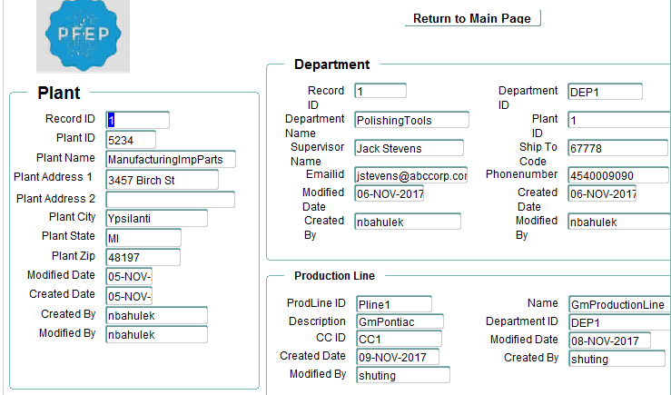

**Location-Feature-Product**

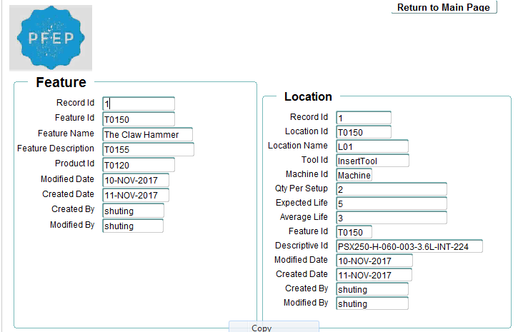

**Machine-Location**

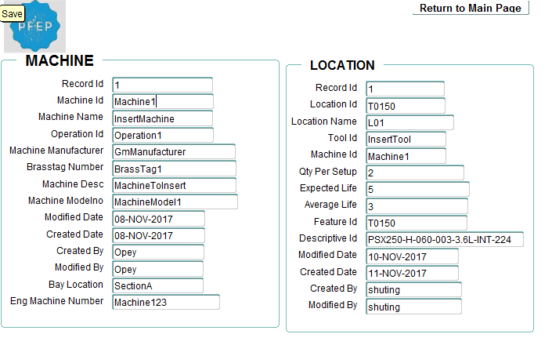

**Machine-Operation**

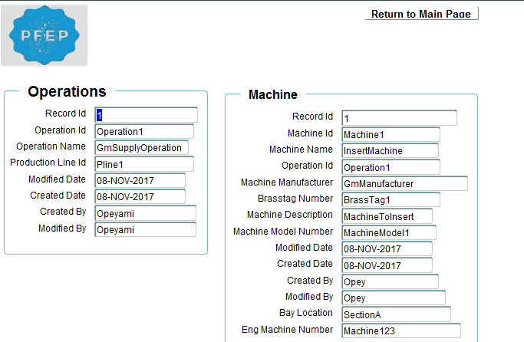

**Tool Location**

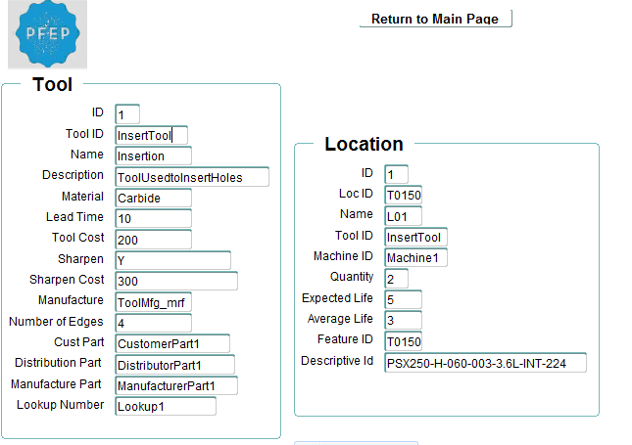

**Budget Cost center**

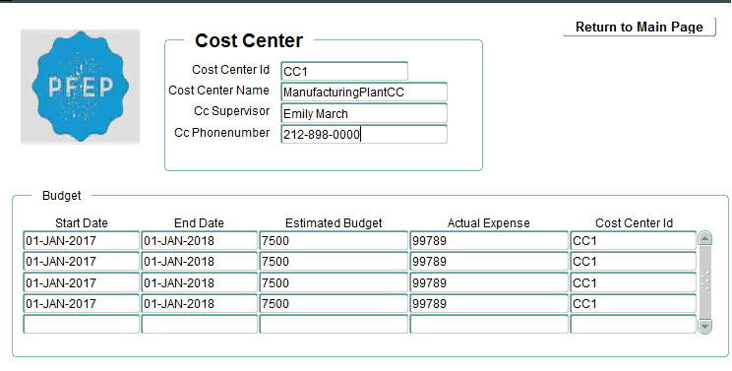

**7.8 Reports**

**Cost Center**

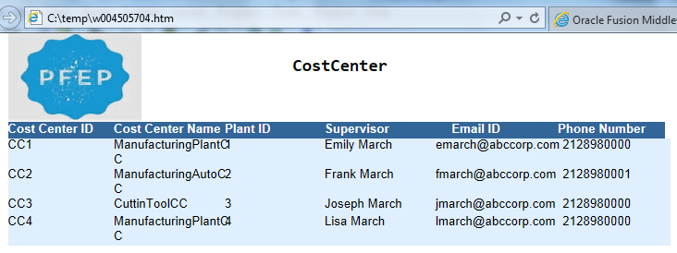

**Engineering Disbursement**

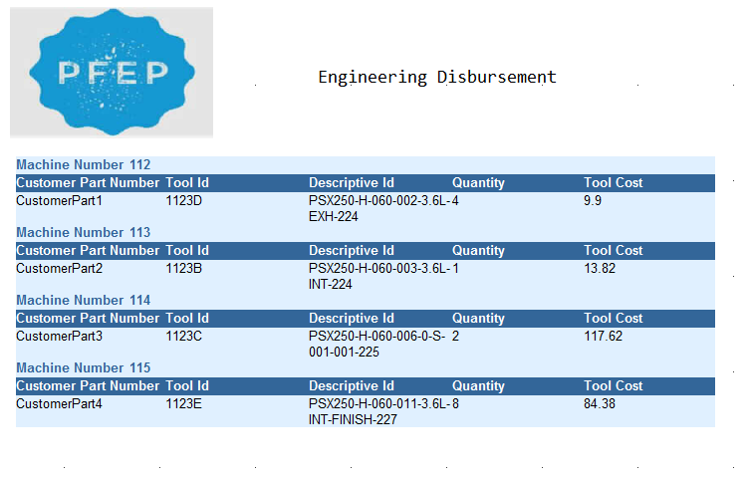

**Financial Disbursement by cost center**

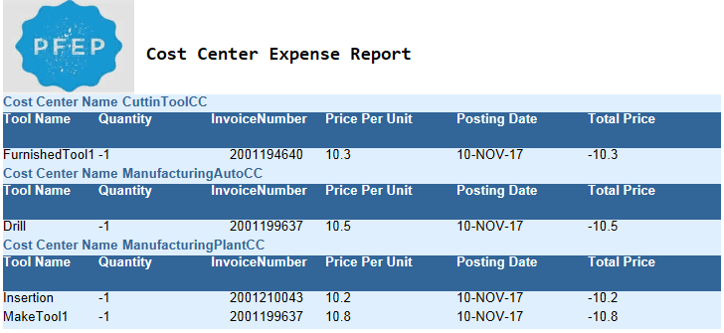

**Production Volume**

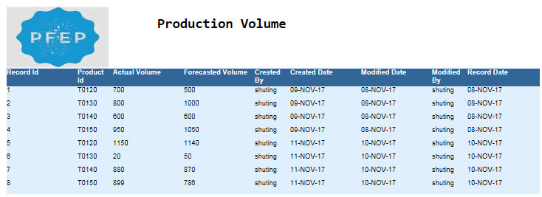

**Budget**

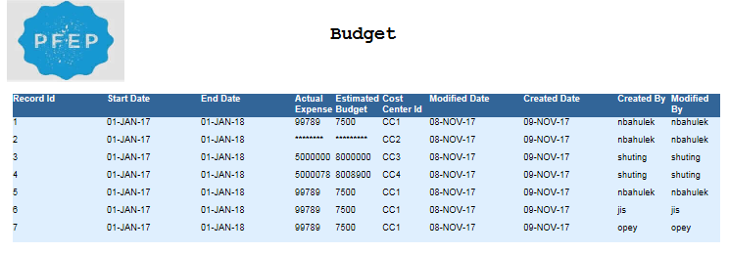

## **CONCLUSIONS**

**8.1 What Have We Learned**

This project has provided a great learning opportunity as we are able to work in a small group and design a PFEP database for a production services company PSMi. We learned how to work collaboratively. we got good guidance from our professor and our stakeholders in all parts of the project. Whenever we are stuck somewhere or having confusions, they are always willing to help us in all feasible way. Gathering the client location on all Fridays and discussing things together in the meeting room help us to realize that we are working for a real product which will be helpful for the company in future. Also, the cooperation from every team member help us to finish our project on time and hand over the deliverable to stakeholder.

Something that has helped the project move forward is the educational background of each of our members. Almost everyone in the team has previous work experience and good in problem solving and team work. Working on this project gave us a good feeling and proud of ourselves as we believe it gave us a chance of enhancing our knowledge and to work as a team.

* 1. **Future Plan**

PFEP database that is being developed by our team will have enormous potential. Right now, the database creation is completed. But there is always a chance of enhancement of database. The database can be improved in future by adding more entities or attributes, if any additional requirements will come in future. Also, there is a possibility of creating an interface for this database. After working on this project so far, we believe that this will help us to work confidently in any real-time work environment and be able to work in a team without any difficulty.

## **REFERENCES**

<http://psmicorp.com>

## **APPENDICES**

**MEETING MINUTES**

**Meeting Minutes – 1**

Meeting 1: Monday, 09.27.2017

Time 3 pm/ Dr. Roumani’s office/ 419 owen

**Attendees**

Opeyami

Jis

Akshata

Absentees

Namita

Shuting

**Agenda**

Discussion Topics with Dr. Roumani

Assuming all data in Excel, can we get sample data?

How many excel sheets is needed per semester- Department info, student info, other.

Efforts needed to manage excel- Daily two hour to update or insert records- Advantages of using database (Finish tasks in less time)

Data Flows ( CIS members in total)

Archives - are we maintaining the history of data? If yes is it in excel sheet itself / moving to cloud?

Any report creation for sharing the data to department committee?

Who all will use the data?

Action Items/Points discussed in meeting/To do

Data managing in excel now, need more effort to manage things.

Getting data from Banner centralized db of EMU

Can have Entities student, course, enrollment, prerequisites, generate sample data using randomgenerator

Create Reports

Discussed with Dr. Chung and he suggested this is too small for 5 people. He needs more than 6 entities.  So, need to find out another real business. Let us have a online meeting tomorrow evening/ saturday evening to discuss more about this.

**Meeting Minutes – 2**

Meeting 2: Oct 4th

Time: After Exam

**Attendees**

Opeyami

Jis

Akshata

Namita

Shuting

Agenda

Review Member Profile

To divide the topics for outline of proposal

**Meeting Minutes – 3**

**Meeting 3:** Oct 5th

Time : After IS 625 Exam

Attendees

Opeyami

Jis

Akshata

**Agenda**

Complete Gantt Chart

**Meeting Minutes – 4**

**Meeting 4:** Oct 10th

Time: 12 pm

Place: 1255 Beach CT, Saline,MI

Client: PSMi [**(https://www.psmicorp.com/**](https://www.psmicorp.com/))

Manager: Subin Babu ([**babu.subin@gmail.com**](mailto:babu.subin@gmail.com)

Contact No: 734-358-9999

**Attendees**

Opeyami

Jis

Akshata

Namita

Shuting

**Agenda**

Assigning Project to Team -PFEP Database

|  |  |  |  |
| --- | --- | --- | --- |
| **Topic** | **Assigned To** | **Due Date** | **Status** |
| WBS | Opey, Jis, akshata | 10/11/2017 | Done |
| Table Structure and Arrangement | Jis | 10/11/2017 | Done |
| Gantt Chart | Opey, Jis, akshata | 10/11/2017 | Done |
| SWOT Analysis, Executive Summary | Namita | 10/11/2017 | Done |
| Company Overview | Shuting | 10/11/2017 | Done |

Work on Project Proposal

**Meeting Minutes – 5**

**Meeting 5**: Oct 19th

Time: 5.30 pm (Expecting IS 625 exam to finish by 5.30)

Place: Computer Lab

**Attendees**

Opeyemi

Jis

Akshata

Namita

Shuting

Agenda

Understanding PFEP

Review sample excel send by Mark

Revise ERD

Understand Hierarchy and Physical Infrastructure

Discuss on FACILITY on detail

Gather all questions

Prepare a presentation with ERD and questions

**Notes:**

Please read the proposal and let us discuss if anything is missed or need to add on it

Read about PFEP and understand the entities and attributes of physical infrastructure in detail

Namita- understand about FACILITY

Akshata - PRODUCT and TOOL PARAMETERS

Jis - MACHINE PARAMETERS and PRODUCTION VOLUME

Shuting -  understand about FINANCIAL DISBURSEMENT

Opey - understand about ENGINEERING DISBURSEMENT

If everyone is prepared on each category and make notes out of it on meeting, it will be easy to discuss and understand.

**Meeting Minutes – 6**

**Meeting 6**: Oct 20th

Time : 3  pm

Place: PSMI

**Attendees**

Opeyemi

Jis

Akshata

Namita

Shuting

**Agenda**

Review ERD

Next steps

Notes

Plant/Building/Facility - basically same. So keep one Entity which is Building

Change Tool Holder Entity to Location (It is not mandatory that every machine needs Tool Holder or Location)

Operation is certain set of activity doing on a machine.

Production Volume is number of products produced or no of tools disbursed by a machine

Actual consumption of Tool is Engineering Disbursement

Cost center related to Production Line and Department. Financial Disbursement is tied to cost center using production line.

Tool # or Location - Theoretical Tool

Tool-Actual Tool

Correct ERD

**Meeting Minutes – 7**

**Meeting 7** : Oct 23rd

Time : 5 pm - 6.15 pm

Place: Google Hangout

<https://hangouts.google.com/group/pAucjA7ONs5rV3rj2>

**Attendees**

Opeyemi

Jis

Akshata

Namita

Shuting

**Agenda**

ERD correction - Akshata

Find attributes for below entities from Excel

Opey

•Plant

• Department

•Cost center

Namita

•Production Line

•Operation

•Machine

Akshata

•Location

•Tool

•Engineering Disbursement

Jis

•Product

•Production Volume

•Feature

Shuting

•Financial Disbursement

Find datatypes of each attributes based on excel data

**Meeting Minutes – 8**

**Meeting 8** : Oct 25th

Time : 5 pm - 6.15 pm

Place: Computer Lab

**Attendees**

Opeyemi

Jis

Akshata

Namita

Shuting

Agenda

ERD completion

Finding datatype of each table

**Meeting Minutes – 9**

**Meeting 9** : Oct 28th

Time : 5 pm - 6.15 pm

Place: hang out

**Attendees**

Opeyemi

Jis

Akshata

Namita

Agenda

Final ERD review

Finalizing Table structure

**Meeting Minutes – 10**

**Meeting 10** : Nov 3rd

Time : 3-5

Place: PSMI

**Attendees**

Opeyemi

Jis

Akshata

Namita

Agenda

ERD review and Table structure review discussion

**Notes**

Analyze remaining things

**Meeting Minutes – 11**

**Meeting 11**: Nov 9th

Time : 5.30-8

Place: Computer Lab

**Attendees**

Opeyemi

Jis

Akshata

Namita

Shuting

**Agenda**

|  |  |  |  |  |
| --- | --- | --- | --- | --- |
| **Topic** | **Assigned To** | **Peer Review** | **Due Date** | **Status** |
| Update ERD | Opey | Akshata | 11/15/2017 | Completed |
| Table Structure | Shuting | Jis | 11/15/2017 | Completed |
| Domains(Attributes, Logical, Physical) | Jis | Akshatha | 11/15/2017 | Completed |
| Constraints(Primary, referential integrity, operational) | Akshata | Opey | 11/15/2017 | Completed |
| *Creating of the Tables*  Oracle (14 tables) - pick in the order in excel sheet | Namita (first 4) ,Opey (next 4), Akshata( next 2),Jis(next 4) | Akshata - Namita’s table  Opey - Akshata’s table  Jis- Opey’s table  Namita- Jis’s table | 11/15/2017 | Completed |
| *Creating of the Tables*  SQL | Namita (first 4) ,Opey (next 4), Akshata( next 2),Jis(next 4) | Akshata - Namita’s table  Opey - Akshata’s table  Jis- Opey’s table  Shuting-Jis’s table | 11/15/2017 | Completed |
| *Adding Data to the Tables*  Oracle | Namita (first 4) ,Opey (next 4), Akshata( next 2),Jis(next 2), Shuting(next 2) | Akshata - Namita’s table  Opey - Akshata’s table  Jis- Opey’s table  Shuting-Jis’s table  Namita- Shuting’s table | 11/15/2017 | Completed |
| *Adding Data to the Tables*  SQL | Namita (first 4) ,Opey (next 4), Akshata( next 2),Jis(next 2), Shuting(next 2) | Akshata - Namita’s table  Opey - Akshata’s table  Jis- Opey’s table  Shuting-Jis’s table  Namita- Shuting’s table | 11/15/2017 | Completed |

**Notes**

Analyze remaining things

Forms

Main Page

Reports

**Meeting Minutes – 12**

**Meeting 12 :** Nov 17th

Time : 3-5

Place: PSMI

**Attendees**

Opeyemi

Jis

Akshata

Namita

Shuting

Agenda

Provide complete database structure deliverable for review

**Notes**

Approved and accepted the database

**Meeting Minutes – 13**

**Meeting 13** : Nov 29th

Time : 5

Place:Lab/Class

Attendees

Opeyemi

Jis

Akshata

Namita

Shuting

**Agenda**

NB: Include PSMi logo (in the drive)  in all pages. Please remember there is a location table already exists in our database. Please delete it first and run the script. Also there should be a return button on each page.

|  |  |  |  |
| --- | --- | --- | --- |
| **Topic** | **Assigned To** | **Due Date** | **Status** |
| **FORMS** | | | |
| Main Page( with all entities and an exit button) | Opey | Nov 30 | completed |
| Department | Jis | Nov 30 | Completed (Need to format) |
| Machine-operation | Shuting | Nov 30 | Need to redo (Ids not matching) |
| Plant-Department-ProductionLine | Akshata | Nov 30 | Need to do alignment |
| machine - Location | Akshata | Nov 30 | completed |
| Feature-location | Akshata | Nov 30 | completed |
| Tools-Location | Namitha | Nov 30 | completed |
| Budget-costcenter | Namitha | Dec 4 | completed |
| **Reports** | | | |
| Financial Disbursement (group above by cost center) | Jis | Nov 30 | completed |
| Engineering Disbursement (group above by machine) | Namitha | Nov 30 | completed |
| Productionvolume group above by product | Namitha | Nov 30 | completed |
| Costcenter (tabular) | Shuting | Nov 30 | completed |
| Budget based on costcenter | jis | Nov 30 | completed |
| Prepare Presentation | Jis | Dec 6 | completed |
| Complete Report | Jis | Dec 6 | completed |